Using the Specialty, Doctor, Patient, Appointment, Allergy, PatientAllergy, Medicine, and PatientMedicine relations created for Hospital System database, populate them with data using the information provided below. If your relations have additional attributes that are not included in the following table list, then add appropriate values to populate your relations with data. 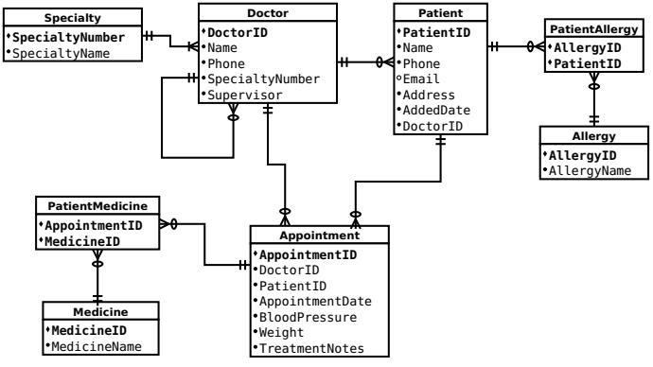

**Assignment Instructions:**

* Provide all the SQL statements required to create the relations
* Populate the relations with data (using SQL insert statements) by using information in below tables
* Issue a select statement for each relation to retrieve data in relations
* Include both the select statement and the output of the select statement (using a screenshot of your database’s output) that shows the contents of each relation
* Create a VIEW to show detailed information about each Patient Hospital Record History.
* Create a Stored Procedure to pull Patient Reports using PatientID as a parameter.

**Specialty Relation**

| **SpecialtyNumber** | **SpecialtyName** |
| --- | --- |
| S1 | Dermatology |
| S2 | Psychiatry |
| S3 | Oncology |
| S4 | Cardiology |
| S5 | Urology |
| S6 | Pediatrics |

**Doctor Relation**

| **DoctorID** | **Name** | **Phone** | **SpecialtyNumber** | **Supervisor** |
| --- | --- | --- | --- | --- |
| D1 | Doctor Karen | 555-1212 | S6 |  |
| D2 | Doctor John | 555-2934 | S2 | D1 |
| D3 | Doctor Robert | 555-6723 | S6 | D1 |
| D4 | Doctor David | 555-1745 | S4 | D1 |
| D5 | Doctor Mary | 555-6565 | S5 | D1 |
| D6 | Doctor Linda | 555-4889 | S1 | D1 |
| D7 | Doctor Susan | 555-4581 | S3 | D1 |
| D8 | Doctor Zeynep | 555-7891 | S4 | D1 |
| D9 | Doctor Mat | 555-7791 | S1 | D1 |

**Patient Relation**

| **PatientID** | **DoctorID** | **Name** | **Phone** | **Email** | **Address** | **AddedDate** |
| --- | --- | --- | --- | --- | --- | --- |
| P1 | D2 | Patient Dana | 444-1212 | P1@email.com | 123 Home St. | 02/01/2019 |
| P2 | D7 | Patient Harry | 444-2934 | P2@email.com | 3435 Main St. | 7/13/2011 |
| P3 | D6 | Patient Karl | 444-6723 | P3@email.com | 2176 Baker St. | 5/10/2009 |
| P4 | D2 | Patient Sid | 444-1745 | P4@email.com | 176 Right St. | 6/20/2010 |
| P5 | D8 | Patient Marry | 444-6565 | P5@email.com | 435 Main St. | 5/18/2014 |
| P6 | D6 | Patient Kim | 444-4889 | P6@email.com | 34 Home St. | 3/15/2018 |
| P7 | D4 | Patient Susan | 444-4581 | P7@email.com | 65 Water St. | 9/07/2011 |
| P8 | D3 | Patient Sam | 444-7891 | P8@email.com | 23 Hill Drive | 11/23/2010 |
| P9 | D5 | Patient Peter | 444-7791 | P9@email.com | 12 River St. | 02/01/2008 |
| P10 | D7 | Patient Nick | 123-1212 | P10@email.com | 335 Bay St. | 7/13/2011 |
| P11 | D9 | Patient Kyle | 123-2934 | P11@email.com | 216 Baker St. | 5/10/2016 |
| P12 | D9 | Patient Garcia | 123-6723 | P12@email.com | 176 Right St. | 6/20/2010 |
| P13 | D4 | Patient Alicia | 123-1745 | P13@email.com | 823 Left St. | 5/18/2015 |
| P14 | D4 | Patient Dan | 123-6565 | P14@email.com | 534 High St. | 3/15/2018 |

**Appointment**

| **AppointmentID** | **PatientID** | **DoctorID** | **AppointmentDate** | **BloodPressure** | **Weight** | **TreatmentNotes** |
| --- | --- | --- | --- | --- | --- | --- |
| A1 | P1 | D2 | 07/01/2019 | 80 | 65 | Dream to success |
| A2 | P13 | D4 | 01/04/2019 | 77 | 88 | Good heart rate |
| A3 | P11 | D9 | 03/22/2019 | 82 | 95 | Many spots |
| A4 | P7 | D4 | 02/01/2020 | 85 | 74 | Fast heart rate |
| A5 | P9 | D5 | 04/13/2019 | 75 | 56 | Reports checked |
| A6 | P3 | D6 | 11/12/2019 | 81 | 96 | Sun light spots |
| A7 | P10 | D7 | 01/29/2020 | 80 | 87 | Early treatment |
| A8 | P9 | D5 | 08/12/2019 | 86 | 92 | Much better |
| A9 | P14 | D4 | 05/18/2019 | 75 | 75 | Good heart rate |
| A10 | P8 | D3 | 11/18/2019 | 76 | 79 | New teeth |
| A11 | P11 | D9 | 06/22/2019 | 78 | 71 | Much better |
| A12 | P2 | D7 | 02/21/2020 | 82 | 86 | Early treatment |
| A13 | P4 | D2 | 08/17/2019 | 81 | 101 | Bad dreams |
| A14 | P6 | D6 | 06/27/2019 | 79 | 49 | Sun light spots |
| A15 | P10 | D7 | 07/29/2020 | 80 | 83 | Early treatment |
| A16 | P7 | D4 | 08/01/2020 | 78 | 79 | Good heart rate |

**Allergy Relation**

| **AllergyID** | **AllergyName** |
| --- | --- |
| AL1 | Drug |
| AL2 | Food |
| AL3 | Skin |
| AL4 | Asthma |
| AL5 | Rhinitis |

**PatientAllergy Relation**

| **AllergyID** | **PatientID** |
| --- | --- |
| AL4 | P1 |
| AL2 | P13 |
| AL3 | P11 |
| AL4 | P7 |
| AL5 | P9 |
| AL1 | P3 |

**Medicine Relation**

| **MedicineID** | **MedicineName** |
| --- | --- |
| M1 | Ativan |
| M2 | Ibuprofen |
| M3 | Omeprazole |
| M4 | Metoprolol |
| M5 | Azithromycin |
| M6 | Codeine |

**PatientMedicine**

| **AppointmentID** | **MedicineID** |
| --- | --- |
| A15 | M1 |
| A2 | M6 |
| A8 | M3 |
| A6 | M3 |
| A15 | M2 |
| A10 | M6 |
| A10 | M2 |
| A4 | M5 |
| A3 | M5 |
| A1 | M2 |